Lab 1 Worksheet Sedimentary Rocks and Depositional Environments Spring 2018
Name ______ (-2 points if missing)
Date _______
Use your lab book, lab and lecture PowerPoints, and internet, and your brain as needed to answer all questions in each of the 2 parts. Please explain everything in your own words.
Part 1 Sedimentary Rocks
- Explain the difference between a quartz arenite and a feldspathic arenite.

- Explain what is meant by provenance

- How do the grains and texture of a clastic rock tell about provenance?

- Describe the difference between an arenite and a wacke.

- Define each of the following:
  - Skeletal remains

  - Intraclasts

  - Ooids

  - Peloids

- Explain the difference between a packstone and a grainstone

- Which type of carbonate is a stromatolite?

- In what order do the evaporites develop?

- How would you classify the rock seen in this image?
  - 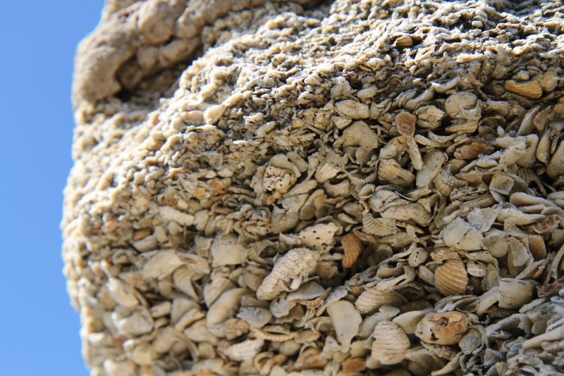

Part 2 Depositional Environments
Use the diagrams in chapter 4, pages 48-58, to answer the following questions. (Caution: images on backside of page from questions)
Part A Figure 4.7 (page 48)
- What is the dominant sedimentary rock type shown in figure 4.7?

- What does the red color suggest about the environment of deposition?

- Rocks of the North Horn Formation were most likely deposited in which of the sedimentary environments listed in table 4.1. Explain your answer.

  - Explain:
Part B Figure 4.8 (page 50)
- What is the dominant sedimentary rock type shown in figure 4.8?

- What economically important sedimentary rock occurs in this outrcrop?

- Rocks of the Blackhawk were most likely deposited in which of the sedimentary environments listed in table 4.1? Explain your answer.

  - Explain:
Part C Figure 4.9 (page 52)
- What two sedimentary rocks types predominate in this formation?

- Rocks of the Cedar Mountain formation were most likely deposited in which of the sedimentary environments listed in table 4.1? Explain.

- Thinking question: Why would dinosaur bones be found more complete in shale than in sandstone.

Part D Figure 4.10 (page 54)
- What is the dominant sedimentary rock type shown in figure 4.10?

- What does the black color suggest about the environment of deposition?

- What additional information is provided by the types of fossils found in the Mancos Shale?

- Rocks of the Mancos Shale were most likely deposited in which of the sedimentary environments listed in table 4.1? Explain your answer.

  - Explain:
Part E Figure 4.11 (page 56)
- How would you describe bedding within the Moenkopi Formation?

- What do the mudcracks (Fig. 4.11E) suggest about the depositional setting?

- Rocks of the Moenkopi Formation were most likely deposited in which of the sedimentary environments listed in table 4.1? Explain your answer.

  - Explain:
Part F Figure 4.12 (page 58)
- What do the cross-bedding, presence of crinoids, and oolitic nature of the limestone indicate about the environment of deposition?

